Level 2 Experiments
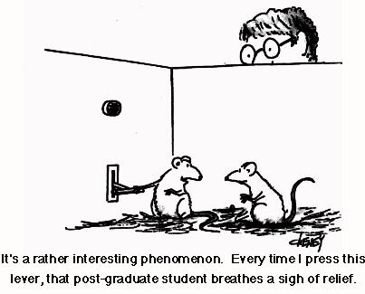

Name:
By Liz Sneddon

Vocabulary List

Bias | 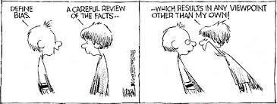 | Something that causes favouritism.
Cause | 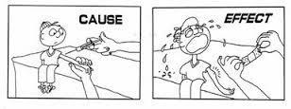 | This is usually the treatment.
Context |  | The real world story or facts behind an experiment.
Control group | 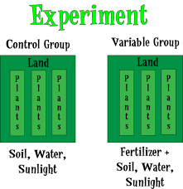 | The group who does not receive the treatment.
Effect |  | The outcome of applying a treatment, measured by the response variable.
Experiment | 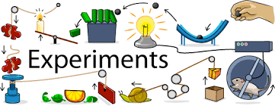 | Process of planning, running, and looking at the results of a test.
Experimental Group  or  Treatment Group | 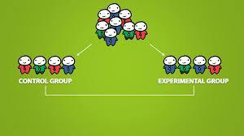 | Group of participants.  or  The group who receives the treatment
Experimental Unit or Participant |  | Single person who is being tested upon in an experiment.
Experimenter |  | Person or group of people in charge of running an experiment.
Hypothesis | 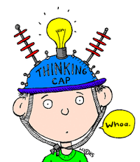 | Predication, or expectation. Usually made before an experiment.
Independent variable | 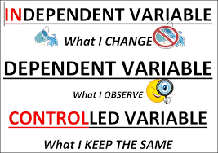 | Usually takes only two values, placebo and treatment.
Median | 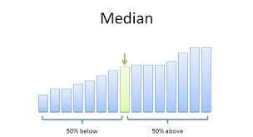 | The central or middle value of an ordered dataset
Paired comparison | 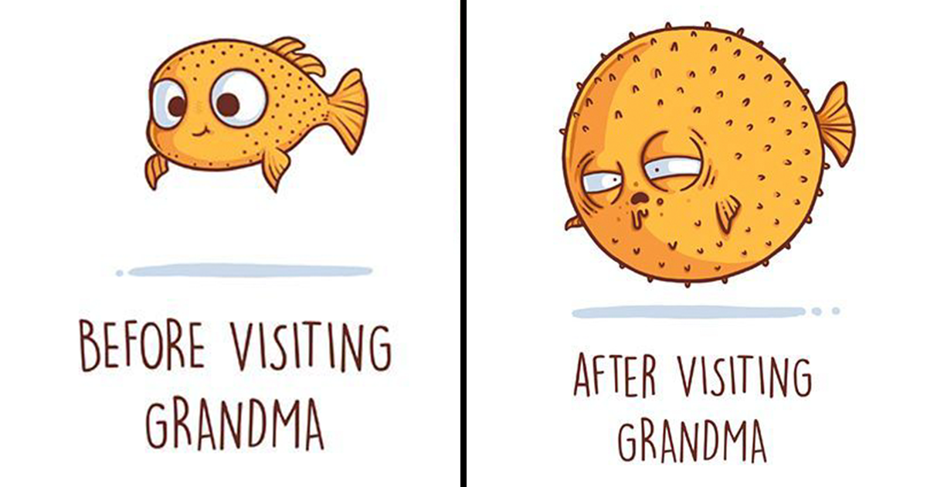 | An experiment on a single experimental group, taking a before and after measurement.
Placebo | 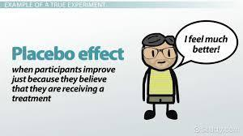 | Simply put, a fake treatment.
Random Allocation | 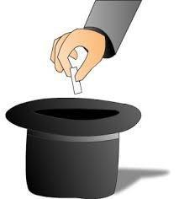 | Process of randomly assigning participants to groups using, for example a deck of cards or flipping a coin.
Response variable  Or  Dependent variable |  | The measurement that is the main focus of an experiment.
Spread | 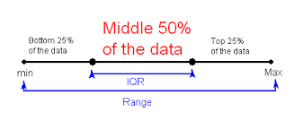 | The spread of the data around the median, measured by the interquartile range (IQR) or standard deviation.
Treatment |  | An applied change or influence that should result in a change in the response variable.
Variable | 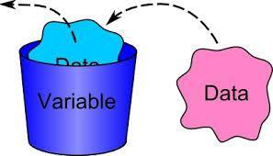 | A measurement, or characteristic (e.g. weight or gender).

What is an experiment?
Watch the ghostbusters video (http://bit.ly/2EOpWrh), and answer the following questions:
1. What was the experiment testing for?

2. What would Dr. Venkman have been recording (writing down)?

3. What was the treatment or stimulus?

4. Is it possible for the subject to have just guessed the correct answer?

5. The experiment is repeated 80 times for each person. If there are 5 possible answers, how many out of 80 would you expect them to get right if they just guessed?

6. How many out of 80 would they need to get right to show evidence of Extra Sensory Perception?

7. Is it a well-designed experiment?

Observational study versus Experimental study
Watch the video (http://bit.ly/2DHw8lx) explaining the difference between an observational study and an experimental study.
With an observational study we can make inferences:

With an experiment we can show cause and effect.

The difference between these is due to the random allocation:

Observational study
Fitness test
Play sport
Fitness test
Don’t play sport

Experimental study
Fitness test
Play sport
Fitness test
Don’t play sport
Randomly allocates

Experiments
In this topic we are only concerned with true experiments. What classifies an investigation as an experiment? There must be an intervention. The experimenter must change just one thing between the groups being studied. All other conditions must be controlled.

Experimental design principles
Issues that need to be considered when planning an experiment:
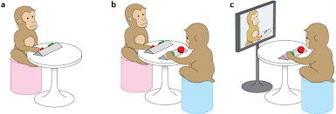

Controlled conditions:
Consider carefully whether you have maintained controlled conditions for each treatment.

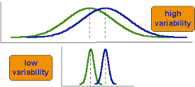
Variability:
A well-designed experiment attempts to minimise unnecessary variability. The use of random allocation of individuals to groups reduces variability, as does larger group sizes. Keeping experimental conditions as constant as possible also restricts variability.

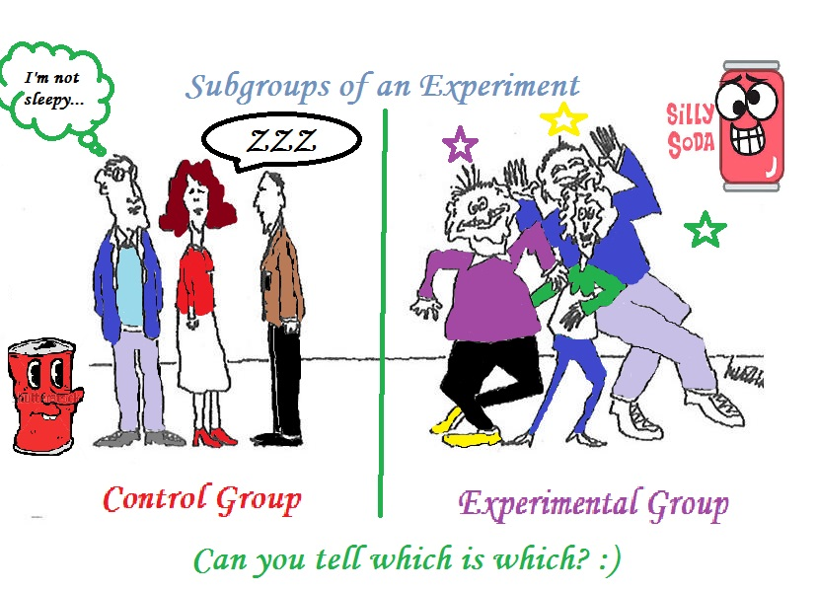
Control Group:
Experiments usually have a control group, a group that receives no treatment or receives an existing or established treatment. This allows any differences in the response, on average, between the control group and the other group(s) to be visible.
For example, we may compare a new cancer treatment with the current cancer treatment (control group).
Or we may compare a new medication with a placebo (sugar pill – control group).
When the groups are similar in all ways apart from the treatment received, then any observed differences in the response (if large enough) among the groups, on average, is said to be caused by the treatment.

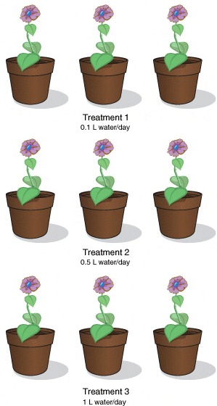
Repeated measurements:
For some experiments, it may be appropriate to carry out repeated measurements. Taking repeated measurements of the response variable for each selected value of the explanatory variable is good experimental practice because it provides insight into the variability of the response variable.
A paired comparison (which we will see later) is an example of this.

Random allocation
When we are comparing 2 groups of people, we need to be sure that both groups are very similar in everything except the one variable we want to measure.

For example, we want all the following factors to be similar in both groups:
• Ethnicity
• Gender
• Time of day that the test is done
• Environment
• Etc.

It isn’t easy to make sure all these and other factors are similar in both groups, but there is another way we can do this. By randomly allocating people into the two groups, this will randomly balance these other factors.

How do we do this?
The easiest way is to have pieces of paper with either A or B written on it, and allocate A to be one group and B to be the second group.
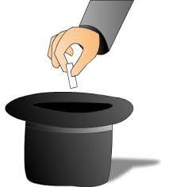
You could also use other methods, such as:
- Use a deck of cards – black cards versus red cards
- Tossing a coin,
- Rolling a die,
- Generating a random number on the calculator,
- Etc.

Example
- I have 30 students that I want to put into 2 test groups. I select 15 black cards from a deck of cards. These will represent group 1.
- I then select 15 red cards, these will represent group 2.
- I shuffle the cards so that they are randomly mixed.
- I go up to student 1 and give them a card. If it is black they will go into group 1, and if it is red they will go into group 2.
- I hand out a card to each student and then move them into the 2 groups.

Sample size
You have to decide on your sample size.

With a small sample size, it is much harder to find differences. With a larger sample size, you can find differences more easily.
Also, with larger sample sizes, there variation is reduced.
Try to have as many participants as you can.

Remember: you will want a similar number of participants in both the treatment and control groups..

Paired comparison versus 2 Independent groups

We are studying experiments which:
• make a comparison between one treatment and another for the same group (paired comparison).
OR
• make a comparison between a treatment group and a control (2 Independent groups)
Treatment group
Control group

Paired Comparison

Control or Treatment
Randomly allocated order
Treatment or Control
Response variable:
Test or measurement
Response variable:
Test or measurement
Difference = Treatment - Control

With a paired comparison experiment, we need to aware of the fact that we will ask each participant to do 2 tests, a the control and the treatment.
Paired comparison is where 2 tests are done by the same person or object.
You cannot do separate dot plots of before and after and discuss as if they were independent.

Problem
Your investigation question needs (be specific):
- Groups
- Measure
- Participants
- The word “effect”
You also need to make a prediction about what you think will happen.

Example
If you are interested in doing an experiment to see if senior students can write quicker with their dominant or non-dominant hand, our investigation question might be:
I wonder if writing with your dominant hand has an effect on the time (seconds) it takes to write a passage compared with using your non-dominant hand, for students in MAS2 at Ormiston Senior College, in 2018.

Our prediction might be:

I think students can write quicker with their dominant hand rather than their non-dominant hand because the muscles in their dominant hand are used more, stronger, and therefore will help them to write quicker.

Some research to support this:
“There was a general trend for the dominant hand to be faster in manipulating objects than the non-dominant hand in both right- and left-handed individuals.”
This quote supports the idea that students might be faster writing with their dominant hand, and the quote was taken from: http://hth.sagepub.com/content/8/1/4.abstract.

Experiment 1
Throwing balls at a target is often considered to be more difficult if the target is further away, but is this actually the case?
Write an investigation question and a prediction for this experiment.

Plan
The advantage of a paired comparison is that you need fewer participants to collect data from. For example, rather than having 15 students do one test and 15 students do the second test, all 30 students will do both tests, so that your sample size is 30 rather than 15 per group. Increasing the sample size makes differences easier to detect.
You will need to think carefully about whether the order in which the treatments are given will affect the response variable. To control for order, you can randomly assign students to two groups, which do the two treatments in different order.

Instructions
You need to write out a list of very specific instructions that another person could be given to collect the data for your experiment.

Recording data
The team needs to decide on how to set up your data table. You need to think about what data you are going to write down, and what columns you need to have (including headers).
You will want one column with the control groups measurements, and one with the treatment groups measurements.
You will also need an extra column on your table, called “Differences”.

Control group measurements | Treatment group measurements | Difference
…

Writing a plan for your experiment
Your plan should include:
- A description of your participants and your sample size.
- Describing the treatment group and control group.
- Describing the response variable (what you are measuring, and its units).
- Instructions of how you will carry out the experiment. This needs to include:
  - Describing the random allocation of treatment to the participants (how are you going to randomly allocate students to be in either the treatment or control group?)
  - An explanation how you will collect your data and record your results.
- Describe any possible sources of variation (what are some factors that you need to control, so that the only difference in the treatment is the ONE factor you are investigating).

Example
If our investigation question is:
I wonder if writing with your dominant hand has an effect on the time (seconds) it takes to write a passage compared with using your non-dominant hand, for students in MAS2 at Ormiston Senior College, in 2018.

Participants:
Students in MAS2 at Ormiston Senior College, in 2018.

Treatment variable:
Treatment
Control
The treatment is: students (as described above) writing with their non-dominant hand for the experiment.
The control is: students (as described above) writing with their dominant hand for the experiment.

Response variable:
I will be measuring the length of time that students (as described above) take to write a passage twice (once for the treatment, and once for the control - the order is randomly allocated). I will measure this with a stopwatch, and measure it in the number of seconds.
Instructions:
- I will finding the sample size of students present, dividing this in half. This tells me how many students will do the test with their dominant hand first, and how many will do it second.
Dominant -
Non dominant -
Non dominant -
Dominant -
or
- I will have this number of pieces of paper with the words dominant then non-dominant written on (as each student does two tests), or non-dominant then dominant written on it (reverse order).
- Each student will be randomly given a piece of paper, with either Dominant or Non-dominant written on it. There are equal or nearly equal numbers in both groups.
- On the whiteboard a stopwatch will be projected.
- Students need to all get out a pen, and move to make sure that they can see the whiteboard.
- Students will be given their instructions. As soon as the paragraph will be displayed on the whiteboard, the stopwatch will start, and students will copy down the paragraph onto a piece of paper. When they have finished they will look at the time on the stopwatch and record the time on their paper.
- Students will then switch their pen to the other hand and repeat the test, recording the results on their paper.
- Papers will then be collected, and the data will be recorded on a Google Sheet as follows:
Dominant hand time | Non-dominant hand time | Difference in time
…
…
- I will thank the students for their assistance with my experiment.
Sources of variation (controlled factors):
Some of the factors I will control are:
- Giving the instructions clearly at the start, so that all students are clear that they need to track the stop watch time precisely. Otherwise some students may be busy talking to each other and not start all at the same time.
- Distance from the whiteboard. The whiteboard will have a large stopwatch and the passage displaying on the screen. I will need to give instructions to the students to come and sit up close enough to clearly see the screen.
- Using pens or pencils. If all students use the same writing utensil, then the results will be more consistent. For example, a student writing with a pen might write faster because of the speed that the ink flows in the pen.

Experiment 1
Plan
Write a set of instructions on how to carry out your experiment to see whether throwing balls at a target is more difficult if you are further away.
Remember to include:
- Participants,
- Treatment variable,
- Response variable,
- Instructions, and
- Sources of variation.

Data

Collecting data
For the assessment you will need to work in groups of around 3-4 students on the planning and data collection for an investigation. This means that you will work together to run your experiment with a group of students.
The different roles that need to be allocated are:
- Presenter (talking to the students and giving instructions)
- Data Recorder (recording the students data into a table)
- Materials manager (making sure that the group has all the equipment it needs)
- Observation recorder (writing down any observations while the students are doing the investigation)

Entering data into Google Sheets
We will go on to use NZGrapher to analyse our data. This means that we need the data entered into Google Sheets and then copied into NZGrapher (using the “Paste Table” button).

NZGrapher
The next step is to open NZGrapher and Paste Table (all three columns) in.

We now choose the graph type: Paired Experiment.

Next select the two variables.
In this case I want to calculate the
Difference = Non-dominant hand – Dominant hand,

So I need to put the Dominant hand as Variable 1, and the Non-dominant hand as Variable 2.
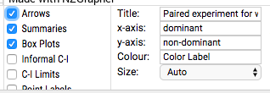
The first graph we want to analyse, is the Arrows graph.

Give the graph a Title and tick the Arrows box.
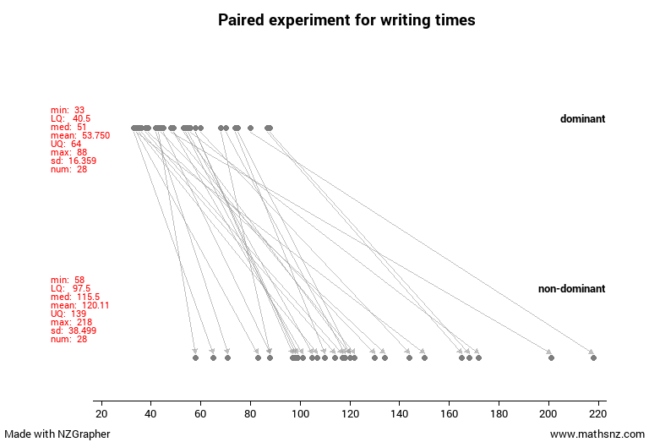

Now the following graph will appear.
Copy and paste this graph into your experiment document.

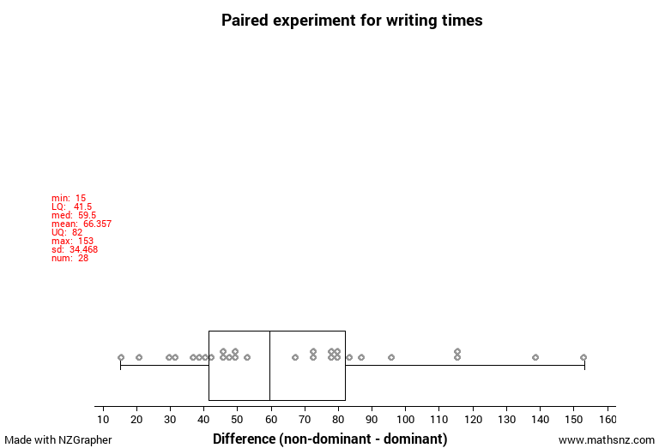
Now untick the Arrows graph, and select:
- Summaries
- Box Plots

Copy and paste this graph into your experiment document.
This is a graph of the differences, which is the second graph you will analyse.

Observations
During the experiment, the observer (and others) may notice behaviour or events that could affect the results of the experiment. It is important that these are noticed, recorded, and discussed. Improvements for future experiments may also be noted (for Excellence).

Example
Observations, effects and improvements:
I noticed that some students were talking while writing the passage. This means that they may have distracted themselves and the person they were talking to. This may have led to them taking longer to write the passage.
If I was to do this experiment again, I would give instructions to students to not talk during the experiment, so that all students have the same conditions, and therefore the results are likely to be only due to the difference in treatment, not due to other factors affecting the results.

Experiment 1
Data
Roles:
Presenter:
Materials manager:
Data recorder:
Observation recorder:

Data:
In Google Classroom a Spreadsheet for entering data is available. All students in the class can open and edit this table (so you can each enter your own data).

Now it’s time to carry out the experiment with the class, following the instructions you created previously, and record your data on the Google Sheet.

Observations:

Next, you need to copy and paste your data into NZGrapher, and get both the arrows graph and the dot plot with a box plot and summary statistics.

Analysis
The analysis that you do is different. Because the two groups that you are comparing (before and after) are NOT independent, we calculate the differences, and then draw two types of graphs – a graph of the differences, and an arrows graph.
Additionally, you analyse the shape, center and spread of the DIFFERENCES (treating it as a single sample).

Analysis 1: Arrows graph
Before Intervention (or control, or treatment one)
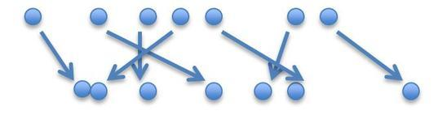
After Intervention (or treatment, or treatment two)
You need to describe what you see only in terms of the direction of the arrows (i.e., the differences).

Example
Each arrow represents a person, and their writing time for their dominant and non-dominant hand.
Notice the arrows going from the dominant hand data values, to the non-dominant hand values.
Each arrow represents how much faster or slower each person writes with their dominant or non-dominant hand.

Exercise:
- How is the difference between the writing speeds represented on this graph?

- What does an arrow going in this direction mean?

- What does an arrow going in this direction mean?

- What does it mean if lots of arrows are going in both directions? E.g.

Example:

From the arrow graph above we can see that all the arrows are pointing in the same direction.
This suggests that all students took longer to write a passage with their non-dominant hand than their dominant hand.

Exercise:
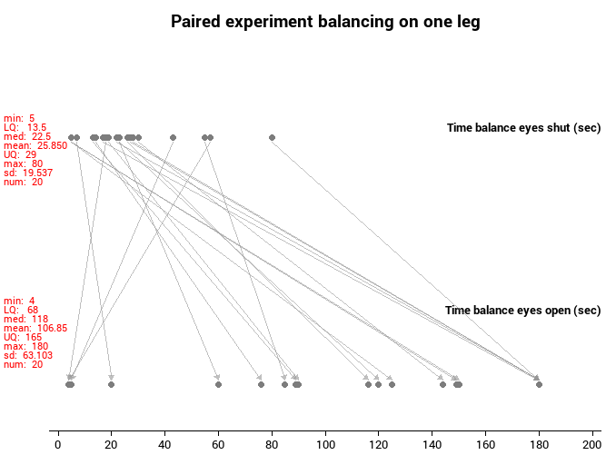
Below is a graph of a paired experiment, where students stood on one leg with their eyes open and again with their eyes closed. Describe any patterns or features.

Experiment 1
Look at the arrow graph you have created for your experimental data. Describe any patterns or features.

Analysis 2 – Differences graphs
NZGrapher calculates the differences for each individual:

After – before,
OR
One treatment – the other treatment

And make a dot plot of the differences (there may be positive and negative differences).
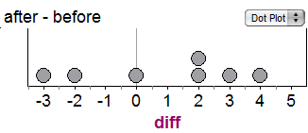
If we now look at how much each person’s data has changed by (e.g. look at each arrow and see the difference), this value now becomes a dot on the dot plot.
3
5
Difference = 2
14
16
Difference = 2
13
12
Difference = -1
This means that each dot represents the difference or change in a person’s data.

Exercise:
A company sends their salespeople to a “customer service” training workshop. Here is the data on the number of complaints they received about customer service before and after the workshop.
Salesperson | Complaints before | Complaints after | Difference = after - before
Person 1 | 6 | 4
Person 2 | 20 | 6
Person 3 | 3 | 2
Person 4 | 0 | 0
Person 5 | 4 | 0

- How do you know that this is paired data?

- Calculate the Differences in the table above.

- Draw an arrow graph to represent the before and after data.
Before
After
Number of complaints
-5 -4 -3 -2 -1 0 1 2 3 4 5 6 7 8 9 10 11 12 13 14 15 16 17 18 19 20

- Draw a dot plot to represent the differences.
Difference in the Number of complaints
-5 -4 -3 -2 -1 0 1 2 3 4 5 6 7 8 9 10 11 12 13 14 15 16 17 18 19 20
- What does each dot represent?

6. If all of the values are positive, what does this mean?

7. If all the values were negative, what would that mean?

8. If the values were both positive and negative, what would that mean?

Example:
The graph is from the experiment on how long it takes to write a passage with students dominant hand versus non-dominant hand. Each student wrote the passage with each hand and recorded the time it took.
Each dot on the graph represents a single student. Specifically, it represents how much longer (or shorter) they took to write the passage with their non-dominant hand, compared with their dominant hand.
I notice that all the values are positive, which tells me that all students in this experiment took longer to write the passage with their non-dominant hand compared with their dominant hand.

Exercise:
Below is a graph of a paired experiment, where students stood on one leg with their eyes open and again with their eyes closed. Explain what each dot represents, and the range of values your plot shows.
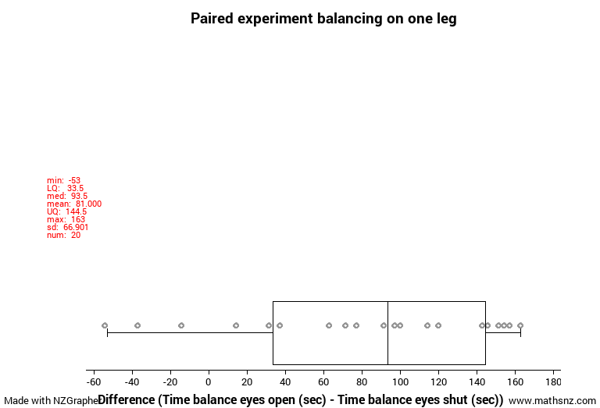

Experiment 1
Look at the dot plot you created for your experimental data. Explain what each dot represents, and the range of values your plot shows.

Features
In your assessment, you will do the analysis and conclusion individually.
Here are the features you need to analyse (the same features as Inference).
- Shape
- Shift – comparing the centers
- Spread – comparing the spread
- Unusual features
Try to link the features to what the data is suggesting about the experiment.

Example
Paired experiment for writing times
Shape:
The shape of the differences between the time it takes students to write with their dominant and non-dominant hand, is right skewed, because there is a long tail on the right hand side, and the data on the left hand side is closely packed.
Center:
I notice that the median difference between the time it takes students to write with their dominant and non-dominant hand is 59.5 seconds. Because this difference is positive, this shows that it takes students a median of around 59.5 seconds longer to write a paragraph with their non-dominant hand, compared to their dominant hand.
I wonder if students write faster with their dominant hand because they use it more and the muscles are stronger?
Spread:
IQR (Difference) = 82 – 41.5 = 40.5 seconds
The spread of the differences between the time it takes students to write with their dominant hand and non-dominant hand has a spread in the middle 50% of 40.5 seconds. That shows that there is a reasonable spread in the time differences.
I wonder if the non-dominant writing times are more spread out because some students non-dominant hands are a lot weaker and have a lot less muscles than their dominant hand, while some students are ambidextrous, and might have similar strength and writing speeds in both hands. This would explain why there is a lot more variation for the non-dominant writing times.
Unusual features:
There does not appear to be any outliers.

Exercise:
Below is a graph of a paired experiment, where students stood on one leg with their eyes open and again with their eyes closed. Describe and justify the features.
Paired experiment balancing on one leg

Experiment 1
Look at the dot plot you created for your experimental data. Describe and justify any features.

Conclusion
In your conclusion you need the following:
- To answer your original question (I wonder …).
- Justify your decision.
- Describe the decision in context, stating specifically who these results can be applied to.
- Discuss improvements or other investigations that this might lead into.

Answering your investigation question
Interpreting the results is different from what we did in Inference. Now the key idea is to think about:
“Since the participants were randomly allocated the order of the treatments, could the results have been just due to chance?
or
Do results tend to be higher for one group/treatment?”

Exercise
- If you were to toss a fair coin, what is the chance that it would be a head?

- If I had 2 arrows , what is the probability I randomly chose either one?

Do results tend to be higher? How do I know?
So if an arrow has a 50% chance of going left or right, then I can compare how many arrows go left and right on my graph. If my graph has around 50% of the arrows going each direction, then the results could be just due to chance.
0%
100%
50%

Values around 50% might be just due to random chance.

Values around 100% are not likely due to random chance.
Values around 0% are not likely due to random chance.
However, if say my graph had around 75% (for a sample size of 20) of the arrows going in one direction, I can suggest that one variable may affect the other variable, for my participants.

You could equally use this same idea looking at the dot plot, and seeing if the whole box sits above or below 0. (Remember that the Lower Quartile has 75% of the data above it, and the Upper Quartile has 75% below it.)

0

0
OR

Note: if you sample size is smaller, you need a percentage larger than 75%.

So the evidence we are looking for is:
- is 75% (or more) of my arrows going in the same direction,
or
- is 75% (or more) of my differences positive (from the dot plot).

There are two conditions we need to meet to be able to suggest that one variable effects the other:
- The experiment has been well designed, and
- The difference in medians is large enough (75% of the data in one group bigger than at least 50% of the data in the other group).

Example:
Conclusion:
Students who wrote with their non-dominant hand tended to take longer to write the passage than students who wrote with their dominant hand. Students writing times with their non-dominant hand were also more variable.
My evidence is that the whole box is above 0 (in fact 100% of the differences is positive).
This leads me to suggest that writing with your dominant hand has an effect on the time it takes to write a passage compared with using your non-dominant hand, for students in MAS2 at Ormiston Senior College, in 2018.
Since I randomly allocated students to write with either their dominant or non-dominant hand first, this supports my suggestion of an effect, as the two groups of students should have been pretty similar in terms of writing speeds.
Improvements:
I could improve my experiment by getting the students to write the paragraph 5 times, and then finding the average of these measurements. This would improve the accuracy of the results.
Limitations:
My experiment was done using students at Ormiston Senior College. This means that the results are only applicable to students at Ormiston who are taking MAS2 in 2018. We cannot assume that these results can be applied to any other students who are younger than 16 or adults over the age of 18. In order to show that younger students can write faster with their dominant hand for example, we would need to run the experiment again with a group of younger students.
Other investigations:
If I ran the experiment again, I could make a small change in the design. For example, I could use a different passage of text, or use something written in a different language (not English).

Exercise:
Below are graphs for a paired experiment, where students stood on one leg with their eyes open and again with their eyes closed. What conclusion would you suggest? Describe and justify.

Experiment 1
Look at the dot plot you created for your experimental data. What conclusion would you suggest? Describe and justify.

This is an example of an paired experiment, where each student does both treatments.
Now you will do a second experiment, with 2 independent groups (the class is separated into two groups and each group has a different treatment).

2 Independent groups
Response variable:
Test or measurement
Control Group
Treatment Group
Randomly allocates
Response variable:
Test or measurement

With 2 independent groups, one group is the control group, and the other is the treatment group. Each participant is only in one group.

Problem
In your investigation question you need the following parts (and be quite specific):
- Groups
- Measure
- Participants
- The word “effect”
You also need to make a prediction about what you think will happen.

Example
If we are interested in doing an experiment to see if senior students can write quicker with their dominant or non-dominant hand, our investigation question might be:

I wonder if writing with your dominant hand has an effect on the time (seconds) it takes to write a passage compared with using your non-dominant hand, for students in MAS2 at Ormiston Senior College, in 2018.

Our prediction might be:
I think students can write quicker with their dominant hand rather than their non-dominant hand because the muscles in their dominant hand are used more, stronger, and therefore will help them to write quicker.

Some research to support this:

“There was a general trend for the dominant hand to be faster in manipulating objects than the non-dominant hand in both right- and left-handed individuals.”

This quote supports the idea that students might be faster writing with their dominant hand, and the quote was taken from: http://hth.sagepub.com/content/8/1/4.abstract.

Experiment 2
We want to do an experiment with the class, to find out if there is any difference in how long students can stand on one leg with their eyes open or eyes closed. We want to compare students who stand on one foot with their eyes open, to those who stand on one foot with their eyes closed, and see if there is any difference between how long students can stand on that foot.
Here is a piece of research that might be helpful:
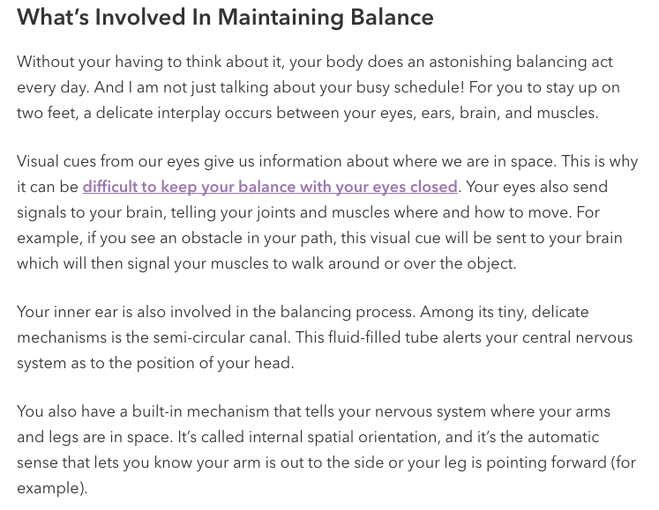
This was taken from: https://saveourbones.com/hows-your-balance-take-this-30-second-test-to-find-out/
Write an investigation question and a prediction for this situation:

Plan
Remember that you need the following information:
- A description of your participants and your sample size.
- Describing the treatment group and control group.
- Describing the response variable (what you are measuring, and its units).
- Instructions of how you will carry out the experiment. This needs to include:
  - Describing the random allocation of treatment to the participants (how are you going to randomly allocate students to be in either the treatment or control group?)
  - An explanation how you will collect your data and record your results.
- Describe any possible sources of variation (what are some factors that you need to control, so that the only difference in the treatment is the ONE factor you are investigating).

Recording data
The team needs to decide on how to set up your data table. You need to think about what data you are going to write down, and what columns you need to have (including headers).
You will want one column with the group that the participant is in (control or treatment) , and one with the response variable (test or measurement).

Control / Treatment | Response
Control group / Treatment group
…

Exercise:
How is this layout of variables different to the paired comparison layout?

Example:
Instructions:
- I will finding the sample size of students present, dividing this in half. This tells me how many students will do the test with their dominant hand first, and how many will do it second.
- I will have this number of pieces of paper with the words dominant or non-dominant written on.
- Each student will be randomly given a piece of paper, with either Dominant or Non-dominant written on it. There are equal or nearly equal numbers in both groups.
- On the whiteboard a stopwatch will be projected.
- Students need to all get out a pen, and move to make sure that they can see the whiteboard.
- Students will be given their instructions. As soon as the paragraph will be displayed on the whiteboard, the stopwatch will start, and students will copy down the paragraph onto a piece of paper. When they have finished they will look at the time on the stopwatch and record the time on their paper.
- Papers will then be collected, and the data will be recorded on a Google Sheet as follows:
Group | Writing time (seconds)
Dominant hand / Non-dominant hand
…

- I will thank the students for their assistance with my experiment.

Exercise:
What differences did you notice compared with the instructions for paired comparison?

Experiment 2
Write a set of instructions on how to carry out your experiment to see if there is any difference in how long students can stand on their dominant foot with eyes open or eyes closed.
Remember to include:
- Participants,
- Treatment variable,
- Response variable,
- Instructions, and
- Sources of variation.

Data

Entering data into Excel
We will go on to use NZGrapher to analyse our data. This means that we need the data entered into Google Sheets and then copied into NZGrapher (using the “Paste Table” button).
One column will be your qualitative variable (groups), and the second column will be your quantitative variable (measurement or counts).

Example
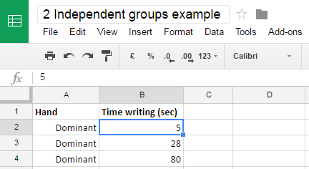

NZGrapher
The next step is to open NZGrapher and Paste Table into the programme,

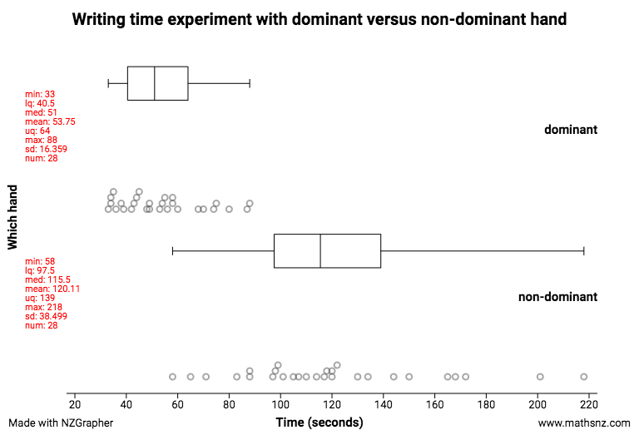
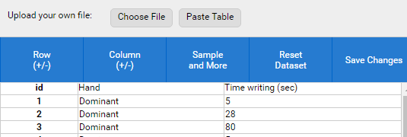
Then you can get the following information:
- Dot plot
- Box and whisker plot
- Summary statistics

Experiment 2
Roles:
Presenter:
Materials manager:
Data recorder:
Observation recorder:

Data:
In Google Classroom a Spreadsheet for entering data is available. All students in the class can open and edit this table (so you can each enter your own data).

Now it’s time to carry out the experiment with the class, following the instructions you created previously, and record your data on the Google Sheet.
Then copy and paste your data into NZGrapher, and get the graphs and statistics that you need.

Observations:
Make notes on student behaviour that might affect the results – e.g. not following instructions, etc.

Analysis
In your assessment, you will do the analysis and conclusion individually.
Here are the features you need to analyse (the same features as Inference).
- Shape
- Shift – comparing the centers
- Spread – comparing the spread
- Unusual features
Try to link the features to what the data is suggesting about the experiment.

Example
Shape:
Both the distributions of time that MAS2 students can write with their dominant and non-dominant hand, are skewed to the right, because they have a longer tail on the right hand side.
Center:
The median time that MAS2 students can write with their dominant hand is around 64.5 seconds quicker than the median time that students can write with their non-dominant hand, which is quite a large difference and may be significant.
The evidence for this is that the median time students can write with their dominant hand is 51 seconds, and the median time for writing with the non-dominant hand is 115.5 seconds.
I wonder if students write faster with their dominant hand because they use it more and the muscles are stronger?
Spread:
IQR (Dominant) = UQ – LQ = 62 – 40.5 = 23.5 seconds
IQR (Non-dominant) = UQ – LQ = 139 – 97.5 = 41.5 seconds
The spread of the middle 50% of data for the time that students can write with their non-dominant hand is nearly twice as spread out than the middle 50% of data for the time that students can write with their dominant hand. The evidence is that the IQR for Dominant hand is 23.5 seconds, and the IQR for Non-Dominant hand is 41.5 seconds.
I wonder if the non-dominant writing times are more spread out because some students non-dominant hands are a lot weaker and have a lot less muscles than their dominant hand, while some students are ambidextrous, and might have similar strength and writing speeds in both hands. This would explain why there is a lot more variation for the non-dominant writing times.
Unusual features:
There does not appear to be any outliers.

Experiment 2
Describe and justify the features of your data:

Conclusion
In your conclusion you need the following:
- To answer your original question (I wonder …).
- Justify your decision.
- Describe the decision in context, stating specifically who these results can be applied to.
- Discuss improvements or other investigations that this might lead into.

Answering your investigation question
The key idea is to think about:
“Since the participants were randomly allocated into groups, could the results have been just due to chance?
or
Do results tend to be higher for one group/treatment?”

Exercise:

- Looking at a box plot, what percentage of the data lies above the Lower Quartile?

- What percentage of the data lies above the median?

- What percentage of the data lies below the Upper Quartile?

- Let’s look at 2 box plots.

Control group
Treatment group
For the Control group, shade in the data below the median.
For the Treatment group, shade in the data above the Lower Quartile.
Do you notice that 75% of the data in the treatment group is bigger than 50% of the data in the control group? This is the evidence we are looking for.

Do results tend to be higher? How do I know?
Shade in 50% of the lower group.
Shade in 75% of the higher group.
Do these areas overlap?
If there is no overlap, then the results tend to be higher for one group.

Example:
75% of the data in one group is not bigger than 50% of the second group, so I would suggest that there is no effect occurring.

50% shaded in
75% shaded in

75% of the data in one group is bigger than 50% of the second group, so I would suggest that there is an effect occurring.

50% shaded in

75% shaded in

There are two conditions we need to meet to be able to conclude that there might be an effect:
- The experiment has been well designed, and
- The difference in medians is large enough (75% of the data in one group bigger than at least 50% of the data in the other group).

Example
Problem:
I wonder if writing with your dominant hand has an effect on the time (seconds) it takes to write a passage compared with using your non-dominant hand, for students in MAS2 at Ormiston Senior College, in 2018.

Conclusion:
Students who wrote with their non-dominant hand tended to take longer to write the passage than students who wrote with their dominant hand. Students writing times with their non-dominant hand were also more variable.
My evidence is that more than 75% of the writing times for non-dominant hands is larger than all of the writing times for the dominant hands.
This leads me to suggest that writing with your dominant hand has an effect on the time it takes to write a passage compared with using your non-dominant hand, for students in MAS2 at Ormiston Senior College, in 2018.
Since I randomly allocated students to write with either their dominant or non-dominant hand, this supports my suggestion of an effect, as the two groups of students should have been pretty similar in terms of writing speeds.
Improvements:
I could improve my experiment by getting the students to write the paragraph 5 times, and then finding the average of these measurements. This would improve the accuracy of the results.
Limitations:
My experiment was done using students at Ormiston Senior College. This means that the results are only applicable to students at Ormiston who are taking MAS2 in 2018. We cannot assume that these results can be applied to any other students who are younger than 16 or adults over the age of 18. In order to show that younger students can write faster with their dominant hand for example, we would need to run the experiment again with a group of younger students.
Other investigations:
If I ran the experiment again, I could make a small change in the design. For example, I could use a different passage of text, or use something written in a different language (not English).

Experiment 2
Draw a conclusion about your data.

